Sir Ellis Kadoorie Secondary School (Shatin)
Yearly Examination 2001 / 2002
Mathematics & Statistics

Secondary 6 Time allowed: 2 hrs
Max. marks : 100

Write your answers in the answer sheets.
Section A (40 marks)
Answer ALL questions in this section.

1. Six boys and two girls are to be seated in a row. In how many ways can this be done if
(a) the two girls must sit next to each other?
(b) the two girls must not sit next to each other?
(c) there is no restriction for the sitting of the two girls? (8 marks)

2. Let $u=e^{2x}$ and $\frac{\text{dy}}{\text{du}}=\frac{1}{u}−2u$.
(a) Express $\frac{\text{du}}{\text{dx}}$ and $\frac{\text{dy}}{\text{dx}}$ in term of x.
(b) It is known that y = 1 when x = 0. Express y in terms of x. (8 marks)

3. The binomial expansion of ${\left(1+x−{\text{ax}}^{2}\right)}^{\frac{−1}{n}}$ in ascending powers of x is $1−\frac{1}{2}x+\frac{\text{11}}{8}x^{2}+\text{.}\text{.}\text{.}\text{.}$, where a is a constant and n is a positive integer.
(a) Find the values of a and n.
(b) State the range of values of x for which the expansion is valid. (8 marks)

4. Let $y=3^{x}$.
(a) Evaluate $\frac{\text{dy}}{\text{dx}}$ and $\frac{d^{2}y}{{\text{dx}}^{2}}$.
(b) Use the trapezoidal rule with 5 sub-intervals to estimate the value of I =$\int{3^{x}\text{dx}}$, correct your answer up to 3 decimal places.

(c) State with reasons whether the approximation in (b) is an overestimate or an underestimate without calculating the actual value of I. (8 marks)

5. Given two curves C₁ : x = y² – 1 and C₂ : x = 5 – y².
y
C₁ : x = y² – 1
A
C₂ : x = 5 – y²

x

B

(a) Let point A and point B be the intersection of C₁ and C₂. Find the co-ordinates of A and B.

(b) Find the area of the region enclosed by the curves C₁ and C_{2.} (8 marks)

– End of Section A –

Section B (60 marks)
Answer any THREE questions in this section. Each question carries 20 marks.

6. Let $y=f(x)=\frac{2x}{x^{2}+1}$.
(a) Show that $f(−x)=−f(x)$. (2 marks)

(b) Find $\frac{\text{dy}}{\text{dx}}$ and $\frac{d^{2}y}{{\text{dx}}^{2}}$. (7 marks)

(c) Find the turning points of $y=f(x)$and determine their natures (maximum, minimum or point of inflexion). (4 marks)

(d) Sketch the curve $y=f(x)$ for $−∞<x<∞$.
Hence sketch (in the same coordinate system) the curve
$y=f(x−1)=\frac{2\left(x−1\right)}{{\left(x−1\right)}^{2}+1}$ (7 marks)
7. (a) In the figure shown, A, B, C and D are the stationary points of the curve $y=x{\left(x^{2}−7\right)}^{3}$. Find their coordinates. (8 marks)

(b) By writing $u=x^{2}−7$ or otherwise, find $\int{x{\left(x^{2}−7\right)}^{3}\text{dx}}$. (5 marks)

(c) Find the total area of the region I and II (the shaded area). (7 marks)
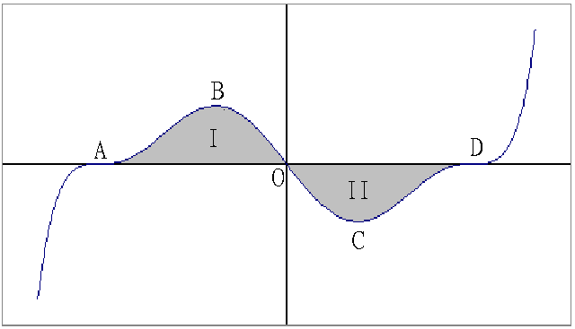

8. A chemical plant discharges pollutant to a lake at an unknown rate of r(t) units per month, where t is the number of months that the plant has been in operation. Suppose r(0)=0.
The government measured r(t) once every two months and reported the following figures:

t | 2 | 4 | 6 | 8
r(t) | 11 | 32 | 59 | 90

(a) Use the trapezoidal rule to estimate the total amount of pollutant which entered the lake in the first 8 months of the plant’s operation. (3 marks)

(b) An environment scientist suggests that $r(t)={\text{at}}^{b}$, where a and b are constants.
(i) Use a graph paper to estimate graphically the values of a and b correct to 1 decimal place. (8 marks)
(ii) Based on this scientist’s model, estimate the total amount of pollutant, correct to 1 decimal place, which entered the lake in the first 8 months of the plant’s operation. (3 marks)

(c) It is known that no life can survive when 1000 units of pollutant have entered the lake. Adopting the scientist’s model in (b), how long does it take for the pollutant from the plant to destroy all life in the lake? Give your answer correct to the nearest month.
(6 marks)

9. Four boys (A, B, C and D) want to play a game. Each of them writes down his name on a piece of paper, and then put all four papers into a bag. Each of them will draw a paper out from the bag in the sequence of A, B, C, D without replacement. The boy, who firstly drew out a paper with his own name on it, wins the game and the game stop. It will be a drawn game (打和) if no one wins the game.

(a) Find P(A) = the probability that A wins the game. (2 marks)

(b) Find P(B) = the probability that B wins the game. (4 marks)

(c) Find P(C) = the probability that C wins the game. (5 marks)

(d) Find P(D) = the probability that D wins the game. (5 marks)

(e) If the rule “without replacement” is now changed to “with replacement”, will the game become a fair game? Explain your reason. (4 marks)

10. A department store has two promotion plans. F and G, designed to increase its profit, from which only one will be chosen. A marketing agent forecasts that if x hundred thousand dollars is spent on a promotion plan, the respective rates of change of its profit with respect to x can be modeled by $f(x)=\text{16}+4{\text{xe}}^{−0\text{.}\text{25}x}$ and $g(x)=\text{16}+\frac{6x}{\sqrt{1+8x}}$.

(a) Suppose that promotion plan F is adopted.
(i) Show that $f(x)≤f(4)$ for x > 0.
(ii) If six hundred thousand dollars is spent on the plan, use the trapezoidal rule with 6 sub-intervals to estimate the expected increase in profit to the nearest hundred thousand dollars.
(10 marks)

(b) Suppose the promotion plan G is adopted.
(i) Show that g(x) is strictly increasing for x > 0. As x tends to infinity , what value would g(x) tend to?

(ii) If six hundred thousand dollars is spent on the plan, use the substitution $u=\sqrt{1+8x}$, or otherwise, to find the expected increase in profit to the nearest hundred thousand dollars.
(7 marks)

(c) The manager of the department store notices that if six hundred thousand dollars is spent on promotion, plan F will result in a bigger profit than G. Determine which plan will eventually result in a bigger profit if the amount spent on promotion increases indefinitely. Explain your answer briefly. (3 marks)

-- End of Paper --

